For unstable or oscillatory responses, the first order linear equation does not represent the input to output relationship in the data. Indicate any system responses that are not a good fit for this equation form.

**Problem 1**

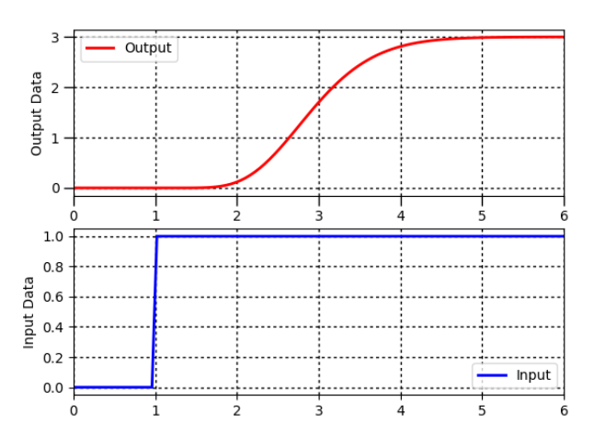

**Solution**

1. Find Δy from step response = 3
2. Find Δu from step response = 1
3. Calculate Kp=ΔyΔu = 3 deg C/(kg/s)
4. Find θp, apparent dead time, from step response = 1.2 sec
5. Find 0.632Δy from step response = 1.9
6. Find t0.632 for y(t0.632)=0.632Δy from step response = 3.1
7. Calculate τp=t0.632−θp. = 3 – 2.1 = 0.9 sec

**Problem 2**

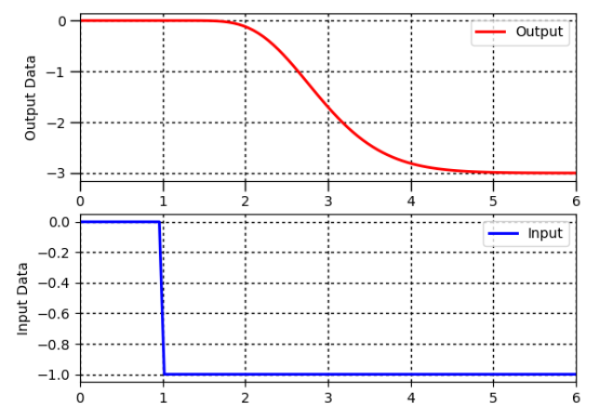

**Solution**

1. Find Δy from step response = 3
2. Find Δu from step response = 1
3. Calculate Kp=ΔyΔu = 3
4. Find θp, apparent dead time, from step response = 1.2 s
5. Find 0.632Δy from step response = -1.9
6. Find t0.632 for y(t0.632)=0.632Δy from step response = 3.2
7. Calculate τp=t0.632−θp. = 3.2-2.1 =1.1

Kp = 3

Θp = 1.2 s

Τp = 1.1 s

**Problem 3**

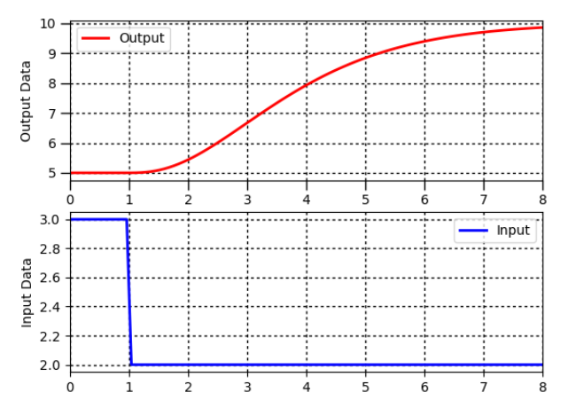

**Solution**

1. Find Δy from step response = 5
2. Find Δu from step response = 1
3. Calculate Kp=ΔyΔu = 5
4. Find θp, apparent dead time, from step response = 0.7 s
5. Find 0.632Δy from step response = 8.2
6. Find $t_{0.632}$ for y(t0.632)=0.632Δy from step response = 4.2
7. Calculate τp=t0.632−θp. = 2.5

Kp = 5

Θp = 0.7 s

Τp = 2.5 s

**Problem 4**

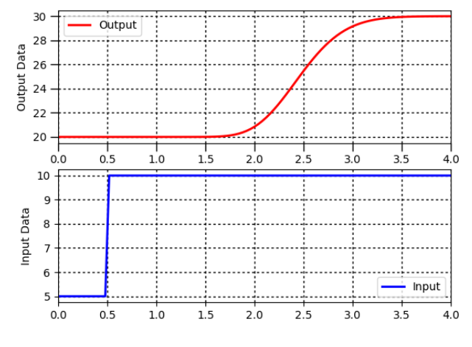

**Solution**

Δy = 10

Δu = 5

0.632* Δy = 6.32

$t_{0.632}$ =2.6 s

Kp = 2

Θp = 1.5 s

Τp = 0.6 s

**Problem 5**

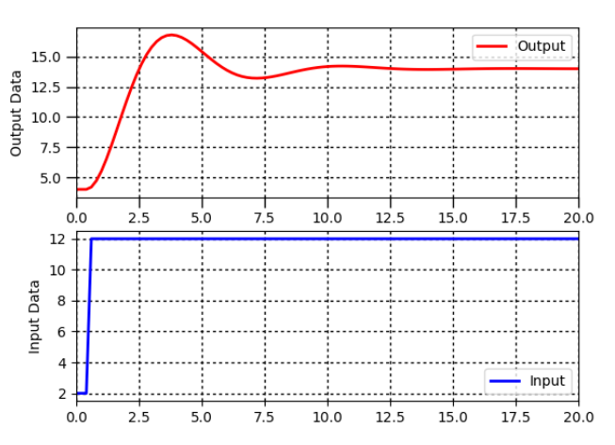

**Solution**

Δy = 12

Δu = 10

0.632* Δy = 8.9

$t_{0.632}$ =

Kp = 1.2

Θp = 0.1 s

Τp = 2 s

**Problem 6**

Not applicable since the output never converges.

**Problem 7**

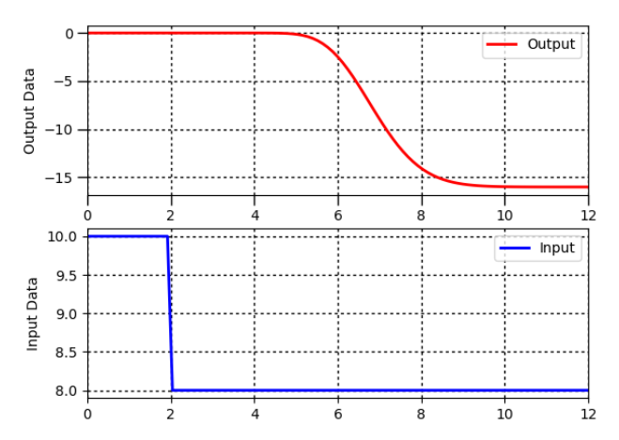

**Solution**

Δy = -16

Δu = -2

0.632* Δy = 10.1

$t_{0.632}$ = 7.1 s

Kp = 8

Θp = 3.3 s

Τp = 7.1 – 5.3 = 1.8 s